

TITLE: Territory Manager

REPORTS TO: Robert Hamilton, VP Sales – Filter Components

LOCATION: Sefar Headquarters Depew NY

General Scope of Position:

The Territory Manager leads the sales activities in assigned geographical area and/or market segment with primary emphasis on Sefar Core Products. Must be technically competent, have good sales and interpersonal skills and knowledge of Sefar’s products, capabilities and applications. Must have good skills on Lotus Notes and windows-based personal computers and commonly used business software.

The employee will be responsible for executing sales objectives and the support of company directed marketing programs. Primary activities will be centered on the sale of Sefar woven and fabricated process filtration solutions, and associated Sefar products to targeted customers and applications within the territory.

Primary Responsibilities of Position:

- Achieve monthly, quarterly and annual sales and margin goals.
- Close sales opportunities at the highest margin percent possible.
- Meet the documentation and administrative responsibilities as given by management.
- Implement specific sales strategies as directed from management.
- Develop adequate sales opportunities to accomplish budgets through prospecting, and cultivation of business.
- Develop and maintain direct contact throughout all levels of the customer’s or prospects organization as needed to develop sales and business agreements.
- Establish an excellent working relationship with key individual(s) at the customer / prospect to facilitate business development.
- Build maximum possible value added into each closed opportunity.
- Communicate with sales management relevant sales situations that could be improved by additional involvement.
- Communicate with sales management new product and application opportunities.
- Attends local, regional and national trade shows / conventions, company sales and training meetings as required.
- Accomplish personal training by establishing and fulfilling annual training program.
- Develop each contacted account to its full potential and exclude competition.
- Travel in the field is expected to be approximately 60 - 80%. Travel to be accomplished within budget.
- Assumes other assignments as directed.

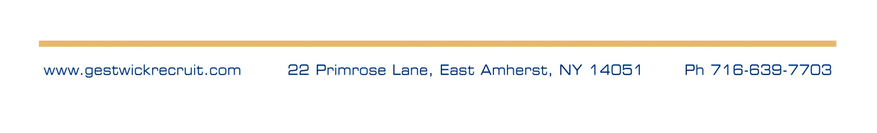
Compensation:

Base $90K and $110K plus a bonus up to 50% of base pay. The position comes with a company car and outstanding benefits!

